**Name: Duration:** 2 hours

**15CSE376**

23.07.2020

**Net Centric Programming Laboratory- Practice session I**

Roll. No: Max. Marks: 20

Evaluation scheme:

Use of appropriate HTML tags : 10 Correct positioning of contents : 5 Output 5

Write HTML code to generate the mock-up webpage given below:

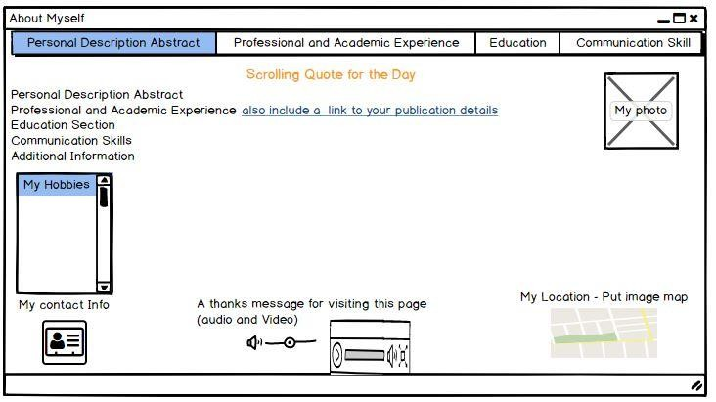

Marks:

|  |  |  |
| --- | --- | --- |
| **Particulars** | **Maximum marks** | **Marks awarded** |
| Usage of tags | 10 |  |
| Positioning | 5 |  |
| Output | 5 |  |
| Total | 20 |  |

Signature of the faculty: